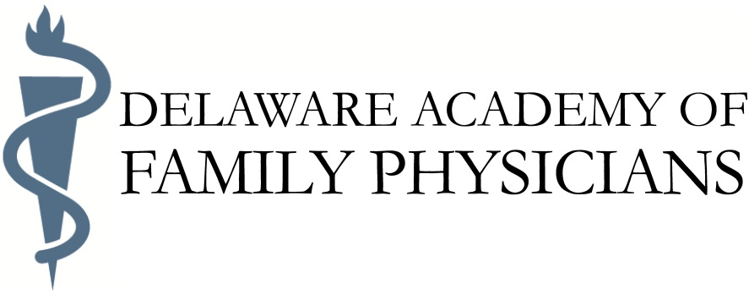

Call for Delaware Family Physician of the Year

The Delaware Family Physician of the Year Award embodies the principles of excellence, combined with comprehensive and compassionate care, for which family physicians are known.

To be considered for the award, a nominee should demonstrate that they:
- Provide their patients with compassionate, comprehensive, and caring family medicine on a continuing basis
- Enhance the quality of their community by being directly and effectively involved in community affairs and activities
- Act as a credible role model professionally and personally in their community, to other health professionals, and residents and medical students.

Additional Requirements:
- Must have practiced family medicine in Delaware for at least ten consecutive years
- Must be Board-Certified in Family Medicine
- Must be a member in good standing in his/her community
- Must be a member of the Delaware Academy of Family Physicians

Nomination materials to be included:
The following materials must be included to be considered:
- Name, address and phone numbers of the nominee
- Name address and phone numbers of the nominating individual
- A letter of nomination (no more than two pages)
- A current CV
- Three letters of support – two (2) from colleagues and one (1) from a person in his/her community
- Other supportive material, as appropriate (not over 15 pages)

The recipient of the DAFP Family Physician of the Year Award also is presented for consideration for the AAFP Family Physician of the Year Award.

Members wishing to place a candidate in nomination should submit materials to:
DAFP Selection Committee
Raymond Saputelli, MBA, CAE
224 W State St.
Trenton, NJ 08608
ray@delfamdoc.org
Tel & Fax: 302-733-3356

